Dear Member,
The London & South East Relationship Management team are keen to ensure that key updates and information of relevance are communicated to you, and your local law society, periodically.
Please feel free to share the information below more widely with your committees and your membership.
Coronavirus: latest guidance and support
We're making representations to government departments, regulators and agencies, and updating our website with the latest news and guidance.
See below our latest coronavirus (COVID-19) resources:
- new campaign: Return, Restart and Recovery
- guidance on how to consider the best work systems for your organisation
- financial resilience for law firms: Should you take up any of the coronavirus financial assistance schemes?
- what to do if your training is terminated
- can my employer force me to return to the office?
Read our latest advice and updates
Read about our priority issues
Local lockdown regulations published for Leicester
On 3 July 2020, the government published its lockdown regulations for Leicester.
The Ministry of Housing, Communities & Local Government has told the Law Society that the regulations do not as far as they are aware contain any additional restrictions on moving home.
People in Leicester will still be allowed to leave home in order to:
- move
- facilitate a house move
We understand that legal professionals can also continue to support house moves, whilst taking all necessary precautions to prevent the spread of infection.
Read the regulations in full here
100 days in numbers
We have produced an infographic summarising the Law society’s COVID related work and outcomes. Some highlights include:
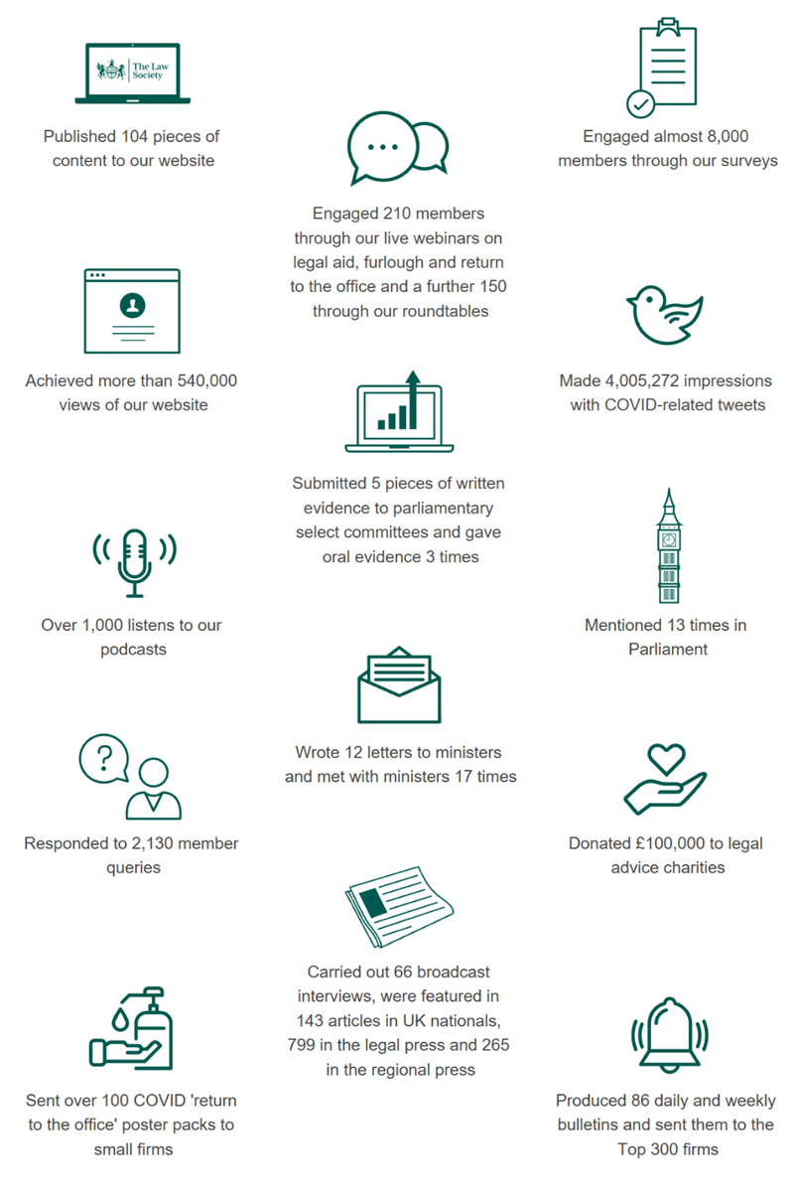
This work resulted in positive developments for the profession:
· The MoJ and the SRA agreeing to allow oaths relating to commercial transactions to be sworn via videolink (although appropriate record keeping will help if the oath’s validity is later challenged).
· The Land Registry to accept Mercury signatures, following our feedback on the difficulties of obtaining wet signatures in the current circumstances.
· The majority of trainees and students being able to still sit their exams, despite the SRA’s initial intention to suspend these.
The full infographic with more metrics and outcomes can be found here on our webpage.
Consultation summary
Revisions to the Attorney General's Guidance on disclosure and the CPIA Code of Practice- closing date extended to 22 July 2020
Link to consultation
Policy Lead: Janet.Arkinstall@lawsociety.org.uk
The Attorney General's Office is consulting on changes to the guidelines and Code of Practice for disclosure.
Tax Treatment of Asset Holding Companies in Alternative Funding Structures- closing date 19 August 2020
Link to consultation
Policy Lead: James.Reynolds@lawsociety.org.uk
This consultation seeks views on whether changes to the tax treatment of companies used by funds to hold assets could make the UK a more attractive location for these companies. It also considers the VAT treatment of fund management fees and other aspects of the UK’s funds regime.
SRA Consultation: SRA Business Plan and Budget 2020-2021- closing date 26 August 2020
Link to consultation
Policy Lead: Marzena.Lipman@lawsociety.org.uk
This consultation takes place, in part, alongside the Law Society Group consultation on the level of the practising certificate fees for 2020/21, which runs until 10 July 2020. The SRA has therefore encouraged responses on the budget component of the business plan prior to 10 July.
As part of this consultation, the SRA is also be asking for views its proposed principles for managing its Compensation Fund, which is a key part of consumer protection and supports public confidence in solicitor firms and the reputation of the profession. Every year the SRA Board decides on the level of the profession's contributions to the fund, based on information about trends, past and prospective claims and interventions.
Notification of uncertain tax treatment by large businesses- closing date 27 August 2020
Link to Consultation
Policy Lead: James.Reynolds@lawsociety.org.uk
From April 2021 large businesses will be required to notify HMRC when they take a tax position which HMRC is likely to challenge. This policy will draw on international accounting standards which many large businesses already follow. This consultation seeks views on the method and detail of the notification and particular areas of uncertain tax treatment.
Call for evidence: raising standards in the market for tax abuse - closing date 28 August 2020
Link to consultation
Policy Lead: James.Reynolds@lawsociety.org.uk
The government has published a call for evidence on raising standards in the market for tax advice. HMRC is seeking evidence about providers of tax advice, current standards upheld by tax advisers, and the effectiveness of the government’s efforts to support those standards, in order to give taxpayers more assurance that the advice they are receiving is reliable.
Consultation on Corporate Tax Rules that apply to Hybrid Mismatch Arrangements- closing date 29 August 2020
Link to consultation
Policy Lead: James.Reynolds@lawsociety.org.uk
The government is consulting on arrangements that exploit the differences in tax treatments between the two jurisdictions. This consultation seeks to ensure that the hybrid mismatch rules work proportionately and as intended.
If you have any questions in relation to any of the above, please do not hesitate to contact us at London&SouthEastTeam@lawsociety.org.uk
Best wishes,
Bhavni, Beth and Stuart.

